Pass Task 10 - Counter

# Related Learning Outcomes

# ULO1 – Explain the OO Principles

This exercise demonstrated the use of an indexer which is a special kind of property that allows the caller to access your object using an index like array. So we could get the Spell values in the Book individually out of the List.

# ULO2 – Use OO Language and Library

Demonstrated class and constructor and property declaration. The task also got us to use Lists to store and access spells in the spell book. We needed to use System.Collection.Generic for the library to access List.

# ULO3 – Design, Develop and Test using an IDE

The code was developed using Xamarin Studio to build and run the program, as well as integrated debugging features to step and inspect values. This task demonstrated creating tests for methods and properties that didn’t exist yet so then we could create them using alt + enter keys and filling them with information so that they would pass the tests.

# ULO4 – Communicate using UML Diagrams

I learned how to interpret a UML class diagram and write the related code. This exercise taught me how to create my own UML diagram for SpellBook and the relationship it has with the Spell Class.

# ULO5 – Describe Elements of Good OO Design

The exercise demonstrated correct use of C# coding conventions.

The exercise used XML commenting to properly document the classes we created in the task.

# Screenshots

[code running]

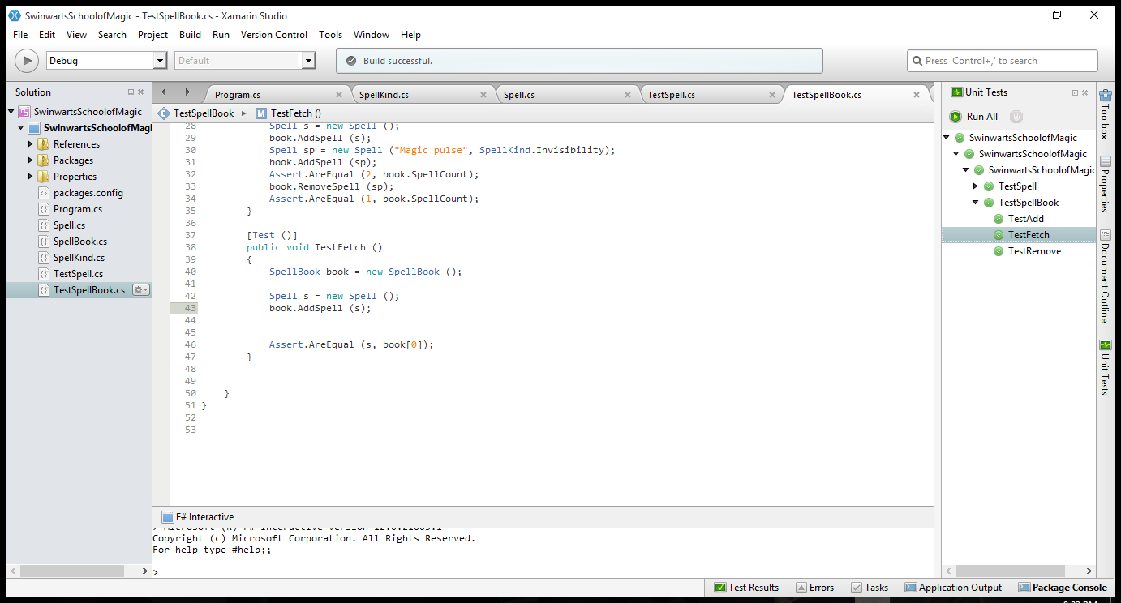

[UML Diagram]

